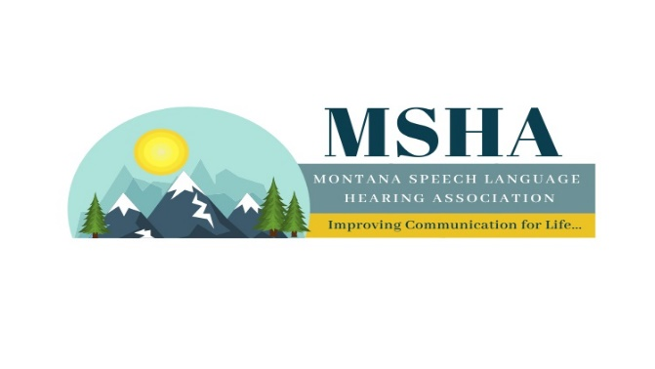
MSHA Awards Nomination Form
NOMINATION FORM DUE BY
OCTOBER 1st

Award Information:
1. Achievement Award: technical and/or professional achievement in fields of speech-language pathology or audiology whose devotion and effort far exceed standard performance

2. Laura Jo McKamey award (aka "Big Purse Award"): someone the exemplifies the heart of volunteerism and has provided exemplary service to MSHA

3. Student Clinical Award: outstanding work in the area of student clinical practice

4. Student Research Award: outstanding work in the area of graduate level research

5. Organization Award: an organization who has made a major contribution to increasing knowledge of, creating tools/techniques for, or had exhibited various attitudes/behaviors in the delivery of services to the communicatively impaired.

6. Off-Site Supervisory Award: exemplary mentorship and supervision for professional students of communication disorders students.

Nominator’s name
Nominator’s contact information | Email:
Nominee’s name
Nominee’s contact information | Email:  Phone/Other way to contact to inform them of their award if they are selected :
Award (Check one) | Achievement award □ | Laura Jo McKamey □ Award | Student Clinical □ Award
 | Organization Award □ | Off-site Supervisory □ Award | Student Research □ Award

Please add additional information below to describe how the nominee demonstrates outstanding qualities for the award for which he/she is being nominated:

